In a similar vein, digitizing government infrastructure and utilizing ICT products increase transparency by decreasing room for wrongdoing, breaking down information monopolies within agencies, and boosting public faith in government (Hao et al., 2023). Attracting investment in renewable energy requires a transparent governance system that is in line with the digital economy. (Fig. 2) shows the oblique association among the digital age and RETI, which supports Assumption 3 and suggests that governance may have a favorable effect on this relationship.

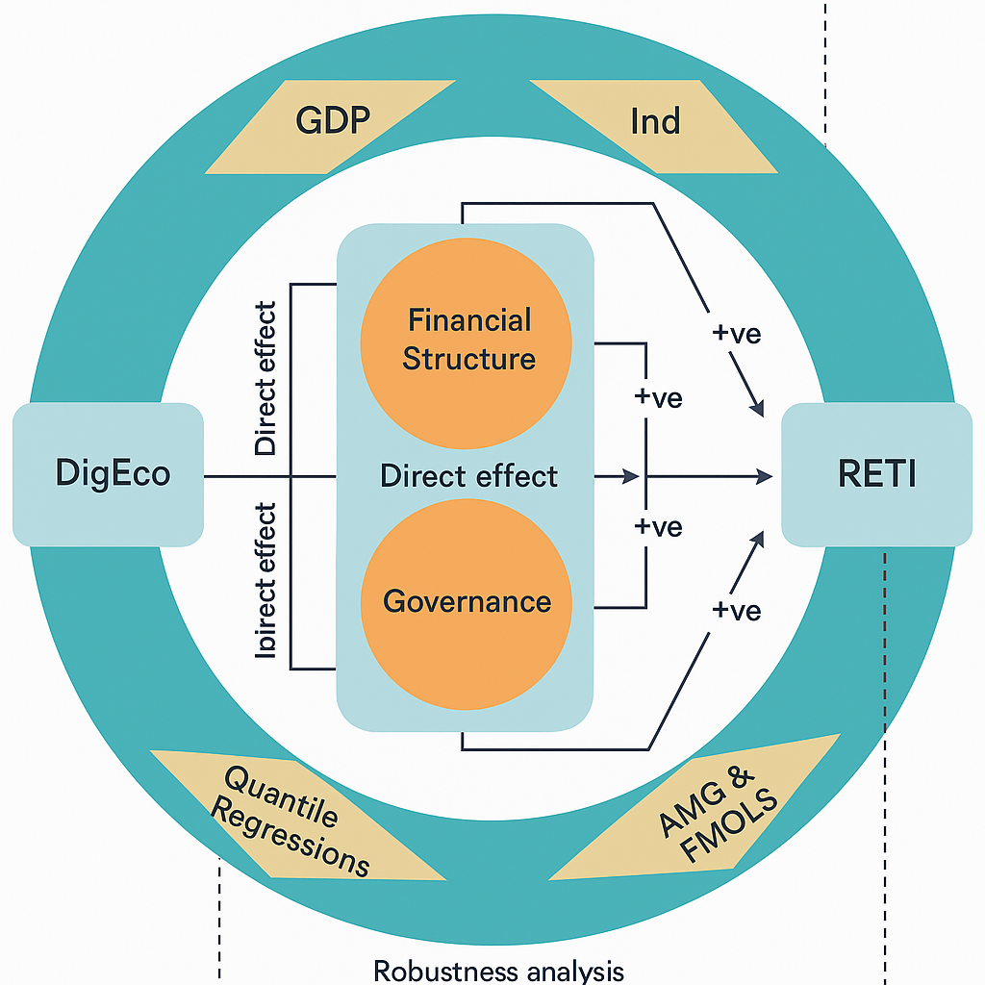

Fig. 2. Guide and oblique channels of digital world's impact on [RETI](https://www.sciencedirect.com/topics/earth-and-planetary-sciences/renewable-energy-technology).

Second, the depth and breadth of financial structures like banks, insurance firms, bonds, and stock markets have been greatly enhanced by the digital economy's integration with conventional financial systems, which has resulted in substantial changes to traditional credit models. Consequently, as numerous industries went digital, financial service allocation became much more efficient within economic systems. Thus, it is crucial to focus on financial development if we want to increase energy sector credit availability, ease financial limitations related to energy technological improvements, and foster innovation through expanded access to and use of financial services.